Narrative Visualisation Project

FIT5197 – Data Exploration and Visualisation

New South Wales’ Air Pollution and Traffic Volume

Stephanie Liem

30829550

Lab 12

Fahimeh Sadat Saleh

# Introduction

## Description

Environment issue has been a serious problem in these past few years, especially air pollution. Around 5000 Australians die from exposure to air pollution only each year, and thousands of other suffers health effects (Environmental Justice Australia, 2019). New South Wales, as the first most popular state in Australia, will also be heavily affected by this issue.

One of the things that can cause air pollution is said to be the gas emitted by vehicles. New South Wales reported of having the largest increase in the number of vehicles (Australian Bureau Statistics, 2017). Thus, we want to know how does NSW’s air condition and if there is any correlation to its traffic volume.

## Audience

The goal of this project is to educate and inform the public, especially the people residing in New South Wales, on the condition of NSW’s air pollution and its relation to traffic volume in an interactive and educative way.

# Design

## Five Design Sheet

### Ideas

The first thing when trying to come up on how to visualize the data is that the three answers of this project must be answered. Thus, the visualization is categorized into four parts which are the yearly trend, pollutants trend, yearly growth and how traffic affects pollution. A couple of graphs are also considered to be used such as bar graphs, line chart, heatmap, choropleth map, pie chart and bubble chart.

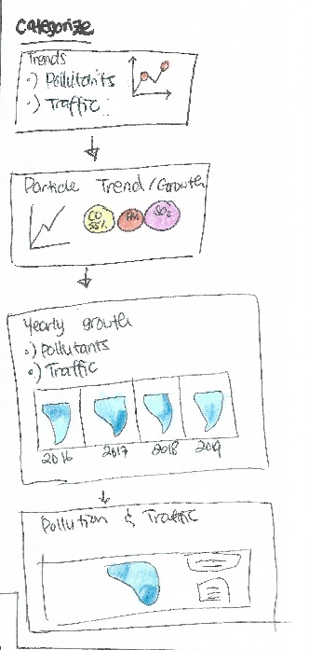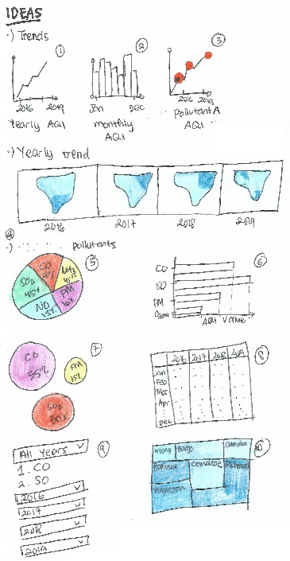

*Figure 1 Design Sheet 1*

### Alternative Designs

#### Dashboard View

*Figure 2 Design Sheet 2*

The first design is to put everything together in one dashboard. There is a choropleth map with the suburbs of New South Wales shown. User can choose which particular year they want to see and click the map on the suburb where they want to see more detail of. According to the user selection, the other graphs will follow. An information box will display the suburb’s information, a bar graph will show the yearly trend, a bubble chart will show the pollutants rate, a heat map will show the monthly trend and a bar chart will show the comparison between traffic and pollution rate.

While it is particularly simple, it shows a lot of information in one page. The human perception can only focus on a small area and with everything changing on the same time, it might be hard on the human eyes to keep up and thus cannot convey the information nicely.

#### Simple Narrative

Another alternative is to make it into a narrative way with simple graphs showing the information. The first page is to show the background of the project. The second one is about the trend of pollution using a line graph, where user can choose the year and month that they want to see. The next page is about the pollutant trend using a bubble chart and line graph where user can click the bubble chart and the line graph will show information of that pollutant according on the user’s selection. Next is a video showing the yearly shift of choropleth map and the last one is about the relationship between traffic and pollution shown according to the suburbs.

#### Complex Narrative

This design is very similar to the one before but just with more complexity. Before showing the graphs, user is asked to play a guessing game first to make things more fun and intrigue their interest. The first information that is shown is the yearly trend of the pollution shown in a bar graph where the user can choose the year they want to see. The next one is about the pollutants which are shown in a bubble chart and their growth rate is shown in a line chart beside it. The yearly shifts are also shown in a choropleth map. The last thing is about the relationship between pollution and traffic shown in bubble chart and bar graph where the areas are divided into the suburbs and metropolitan areas. Finally, the conclusion is shown.

### Final Design

The final design is a combination from all of the alternative ideas above. The dashboard from earlier is being used in the traffic and pollution area while the flow of the pages is a combination of the simple and complex narrative view. A few key important pages are used to make the user to be able to still follow the narrative of the view. Dividing it into several pages also give the user a clearer way to understand the information since it is sectioned.

# Implementation

This project is implemented in a web-based system. It consists of multi pages that are connected using a menu bar. Web-based is chosen since it is more user-friendly and easier to access. Anyone with a web browser can open the website and access its contents. Another reason that web-based is chosen is because the huge amount of library that can be used.

Some of the libraries that are being used are:

1. Javascript
2. JQuery
3. D3
4. Bootstrap
5. WoW

# User Guide

## Main Menu

The first page is the main menu where if the user clicks on the top upper left menu bar, the menu can show up as can be seen in Figure 3b. If the user clicks on of the menu option then they will be redirected to the page containing that particular information.

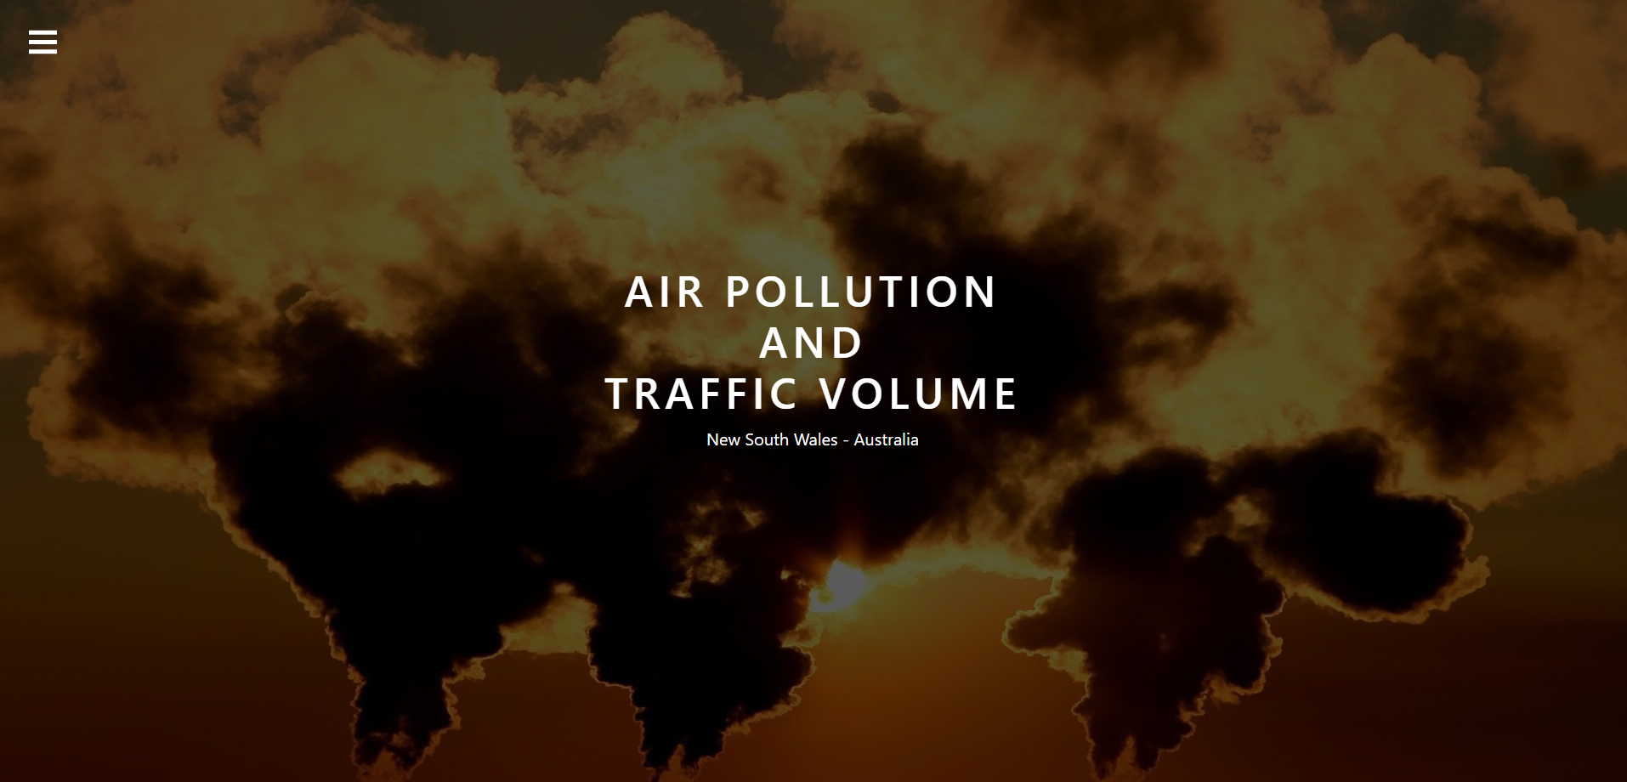

*Figure 3a Main Menu Page*

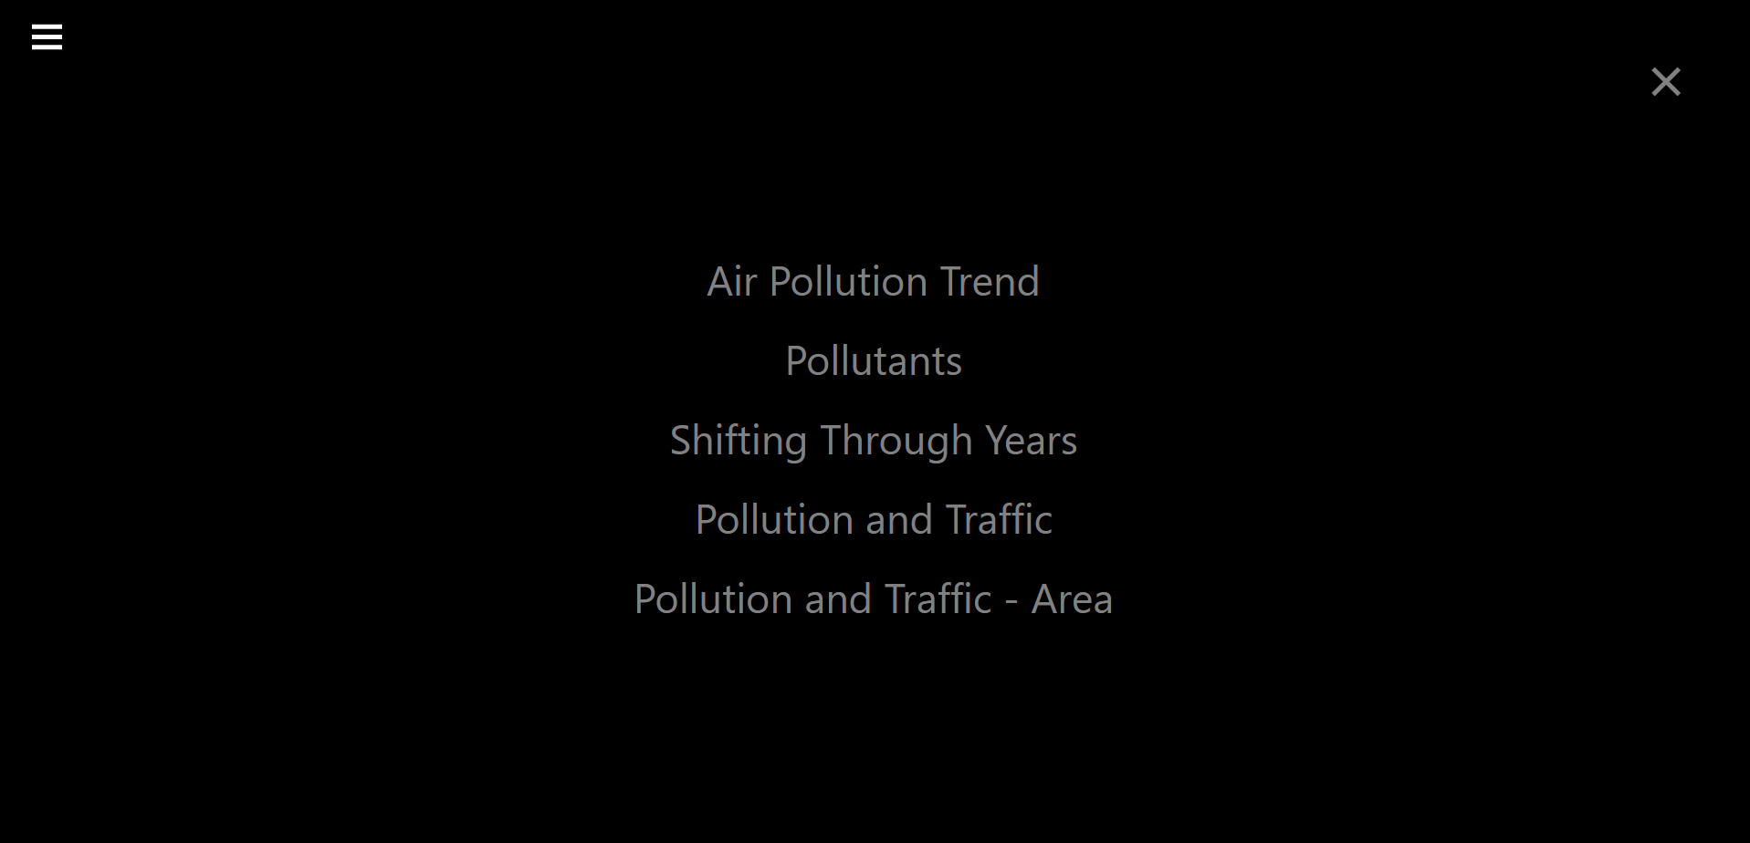

*Figure 3b Menu Bar*

## Yearly Trend

In this page, information about the yearly trend of the air pollution is shown in the line graph on the left. User can hover on one of the points in the chart and a tooltip containing the information of that particular year will show up and the corresponding monthly AQI heat map on the right will be highlighted as seen in figure 4.

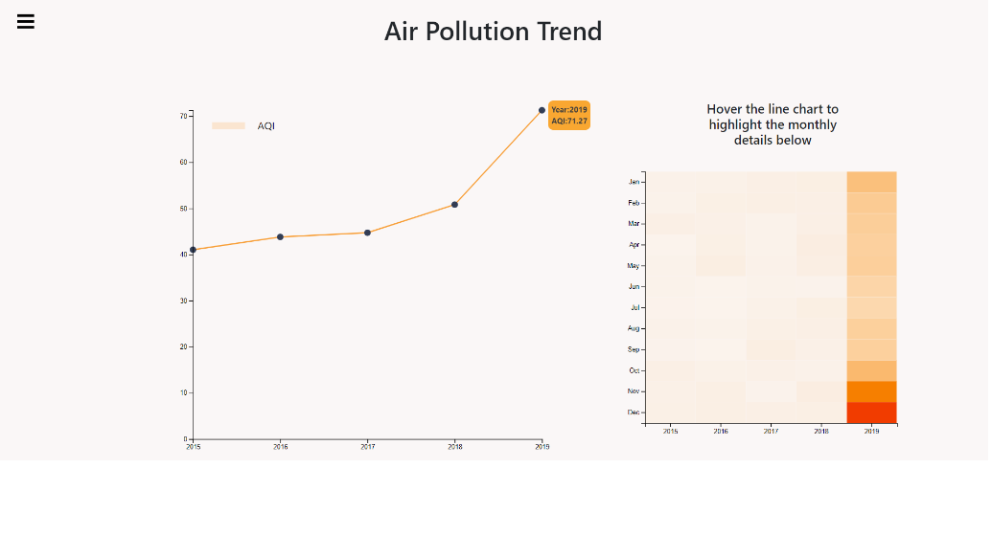

*Figure 4 Air Pollution Trend Chart*

## Pollutants

The next page is about the pollutants information that contributed to the air quality index average. There are six pollutants which are, PM10, Ozone, CO, NO, NO2 and SO2. The first thing on this page are some buttons that user can click and it will show that particular information about the pollutants chosen.

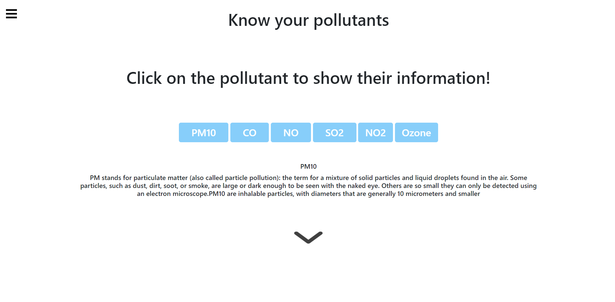

*Figure 5a Pollutants Introduction*

Next, if the user scrolls down then they can see the visualizations as shown in figure 5b. The left bubble chart shows their difference to each of their standard safe value.

Here is the information regarding pollutants and its standard maximum value:

|  |  |
| --- | --- |
| **Pollutant** | **Standard Value** |
| CO | 9 ppm |
| NO2 | 12 pphm |
| NO | 12 pphm |
| Ozone | 8 pphm |
| PM10 | 50 μg/m3 |
| SO2 | 20 pphm |

Table 1 Pollutant and its Standard Value

The data is then plotted by its difference percentage with its standard value, using the formula

$$\frac{value}{standard\max{value}} x 100$$

When we hover on one of the bubbles, a tooltip containing the information will be shown and the line chart on the right will change according to the pollutant which the cursor is currently at. The line chart on the right shows the yearly growth of that particular pollutant.

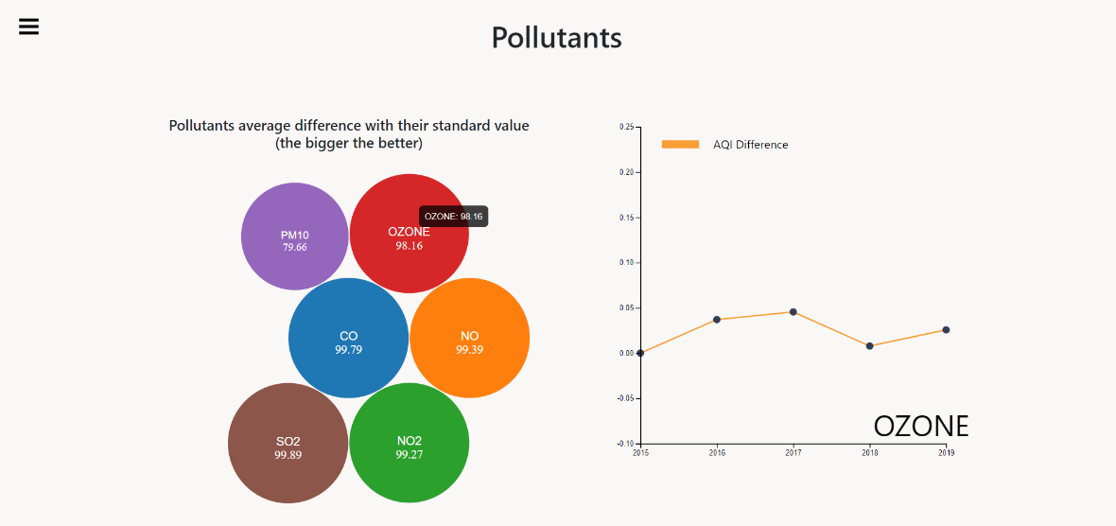

*Figure 5b Pollutants Bubble and Line Chart*

## Shift through years

This page shows the information about the air pollution AQI on a choropleth map. It has a slider on top where user can move to display information regarding that particular year. When user hovers on one of the regions, a tooltip showing that particular area can be seen.

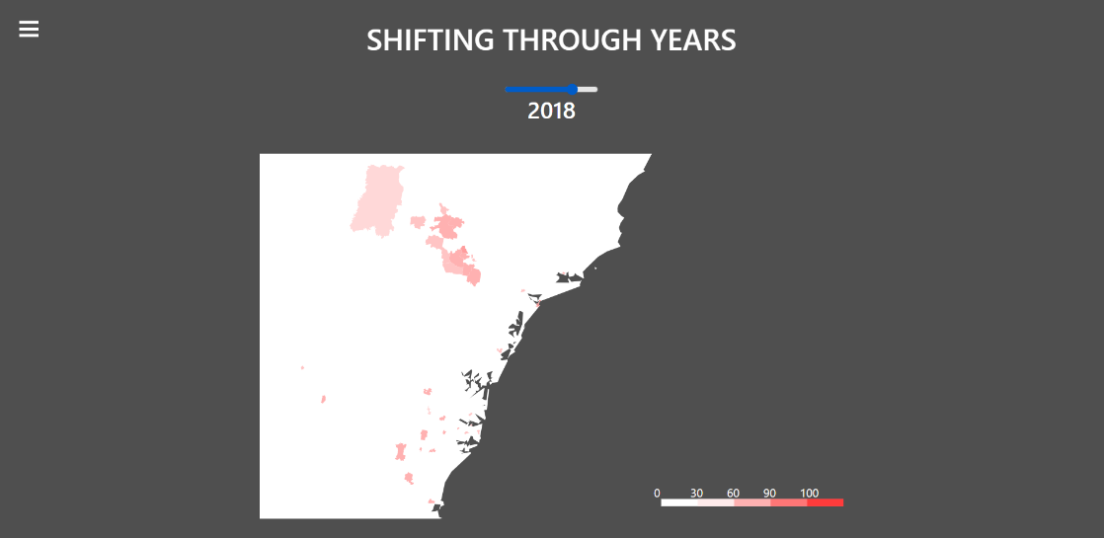

*Figure 6a Air Pollution AQI Year 2018 Choropleth Map*

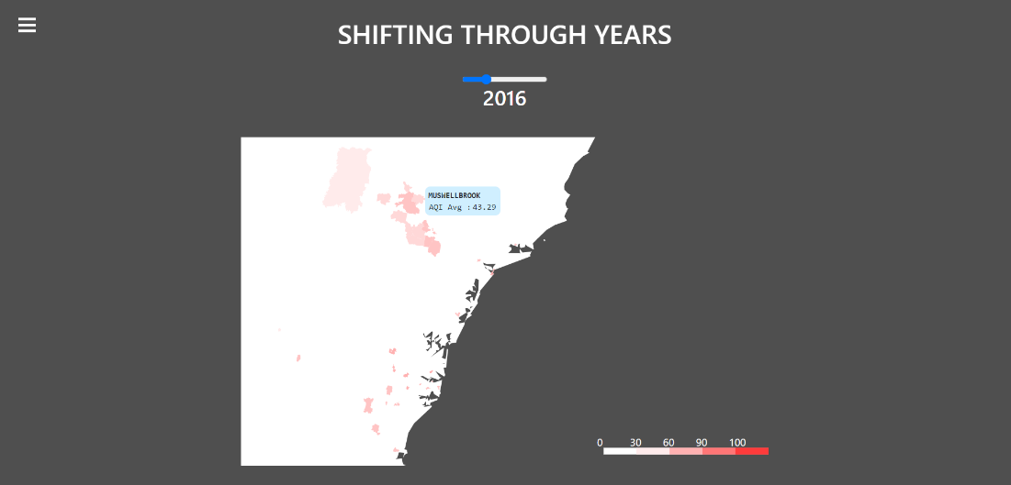

*Figure 6b Air Pollution AQI Year 2016 Choropleth Map with Tooltip*

## Pollution and Traffic

This page shows the information about the ratio of pollution AQI and traffic volume on the suburbs of New South Wales. When one of the areas is clicked, the map will zoom in and focus on that particular suburb. The general information about that area is shown on the right side. It contains information about the suburb name, zip code and its traffic volume and pollution AQI ratio. When the user clicked that particular area again then the map will zoom out again. The slider on the top enable user to choose which year’s information is going to be shown. When the user slides it, the information on the choropleth map will changes according to its value on that particular year.

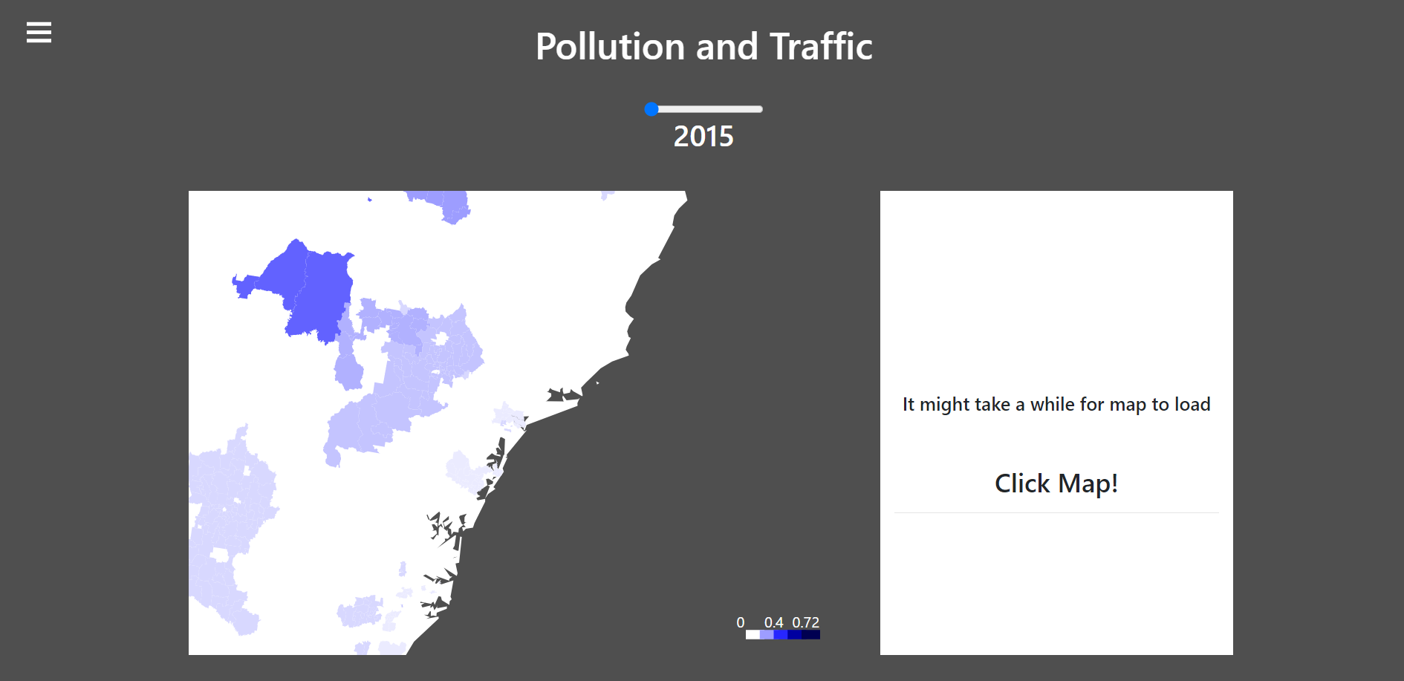

*Figure 7a Pollution and Traffic Map Year 2015*

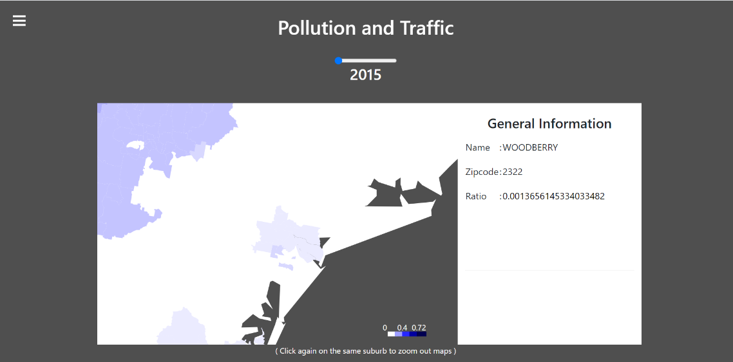

*Figure 7b Pollution and Traffic Map Year 2015 Clicked*

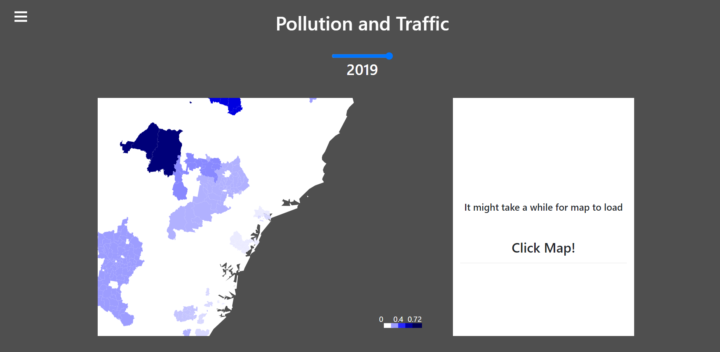

*Figure 7c Pollution and Traffic Map Year 2019*

## Pollution and Traffic – Area

The last page is still about the relation between pollution and traffic but group according to its area. There are three groups here which are Sydney Area, Newcastle Area and Suburb Area. On the left side we can see a pie chart showing the traffic volume percentage rate while on the right side is a bar chart showing the air pollution AQI. When user hovers on one of the areas of the pie chart, a tooltip showing the value of the percentage of that particular area is shown and its corresponding air quality AQI on the right bar chart is highlighted.

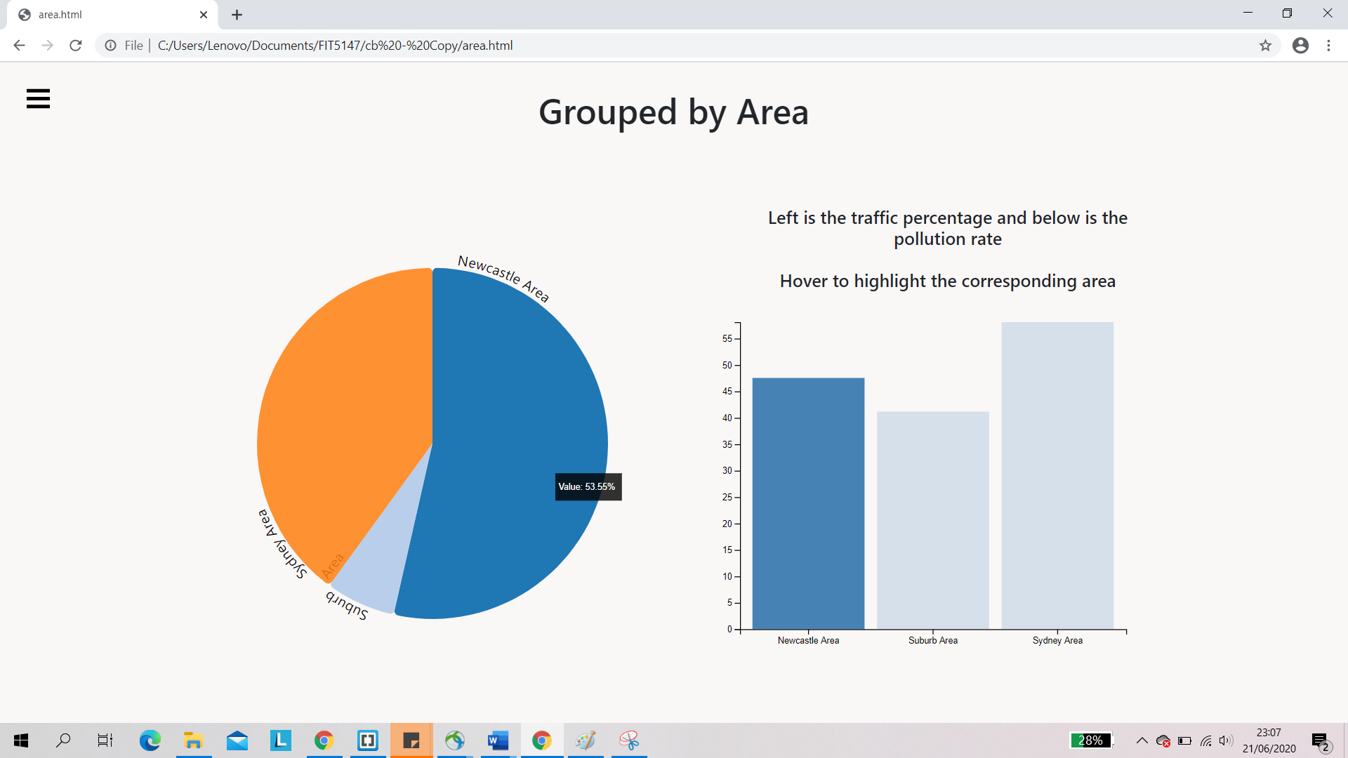

*Figure 8 Pollution and Traffic Grouped Page*

# Conclusion

By making this project, I learned that a good visualization is needed for people to understand information. User will likely to get interested if the visualization uses interesting colors and interactions. User interactions, especially, make the user more involved and curious to know more.

That being said, it is not easy to build an interactive user interface for visualization. When doing this project, it is very hard for me to be able to produce the choropleth map in d3. D3 only has a function for US states and suburbs only, thus I have to search for NSW’s geojson file and draw it manually. The geojson file that I found needs to be cleaned manually since the size is too big for the website to load. Another thing that is quite challenging is to connect one graph to another. It took me a considerably long time to be able to achieve this feature. In the end, I learned a lot on how to make more complex and advance graphs in D3.

One of the things that might have been better is the choropleth map. It might have been smoother and the border line can be made clearer. Another approach to make things clearer for the user is to add the suburb name on the choropleth map itself. Some text introductions might also be better to be placed before the graphs to make the user understand the information more.

# Bibliography

Environmental Justice Australia. (2017). *Reducing the health and environtal burden of coal-fired power.* Retrieved from https://www.envirojustice.org.au/our-work/community/air-pollution/

Australian Bureau of Statistics. (2017). *9309.0 – Motor Vehicle Census, Australia, 31 Jan 2017*. Retrieved from <https://www.abs.gov.au/AUSSTATS/abs@.nsf/Lookup/9309.0Main+Features131%20Jan%202017?OpenDocument>

# Appendix

Page 1 of five design sheet

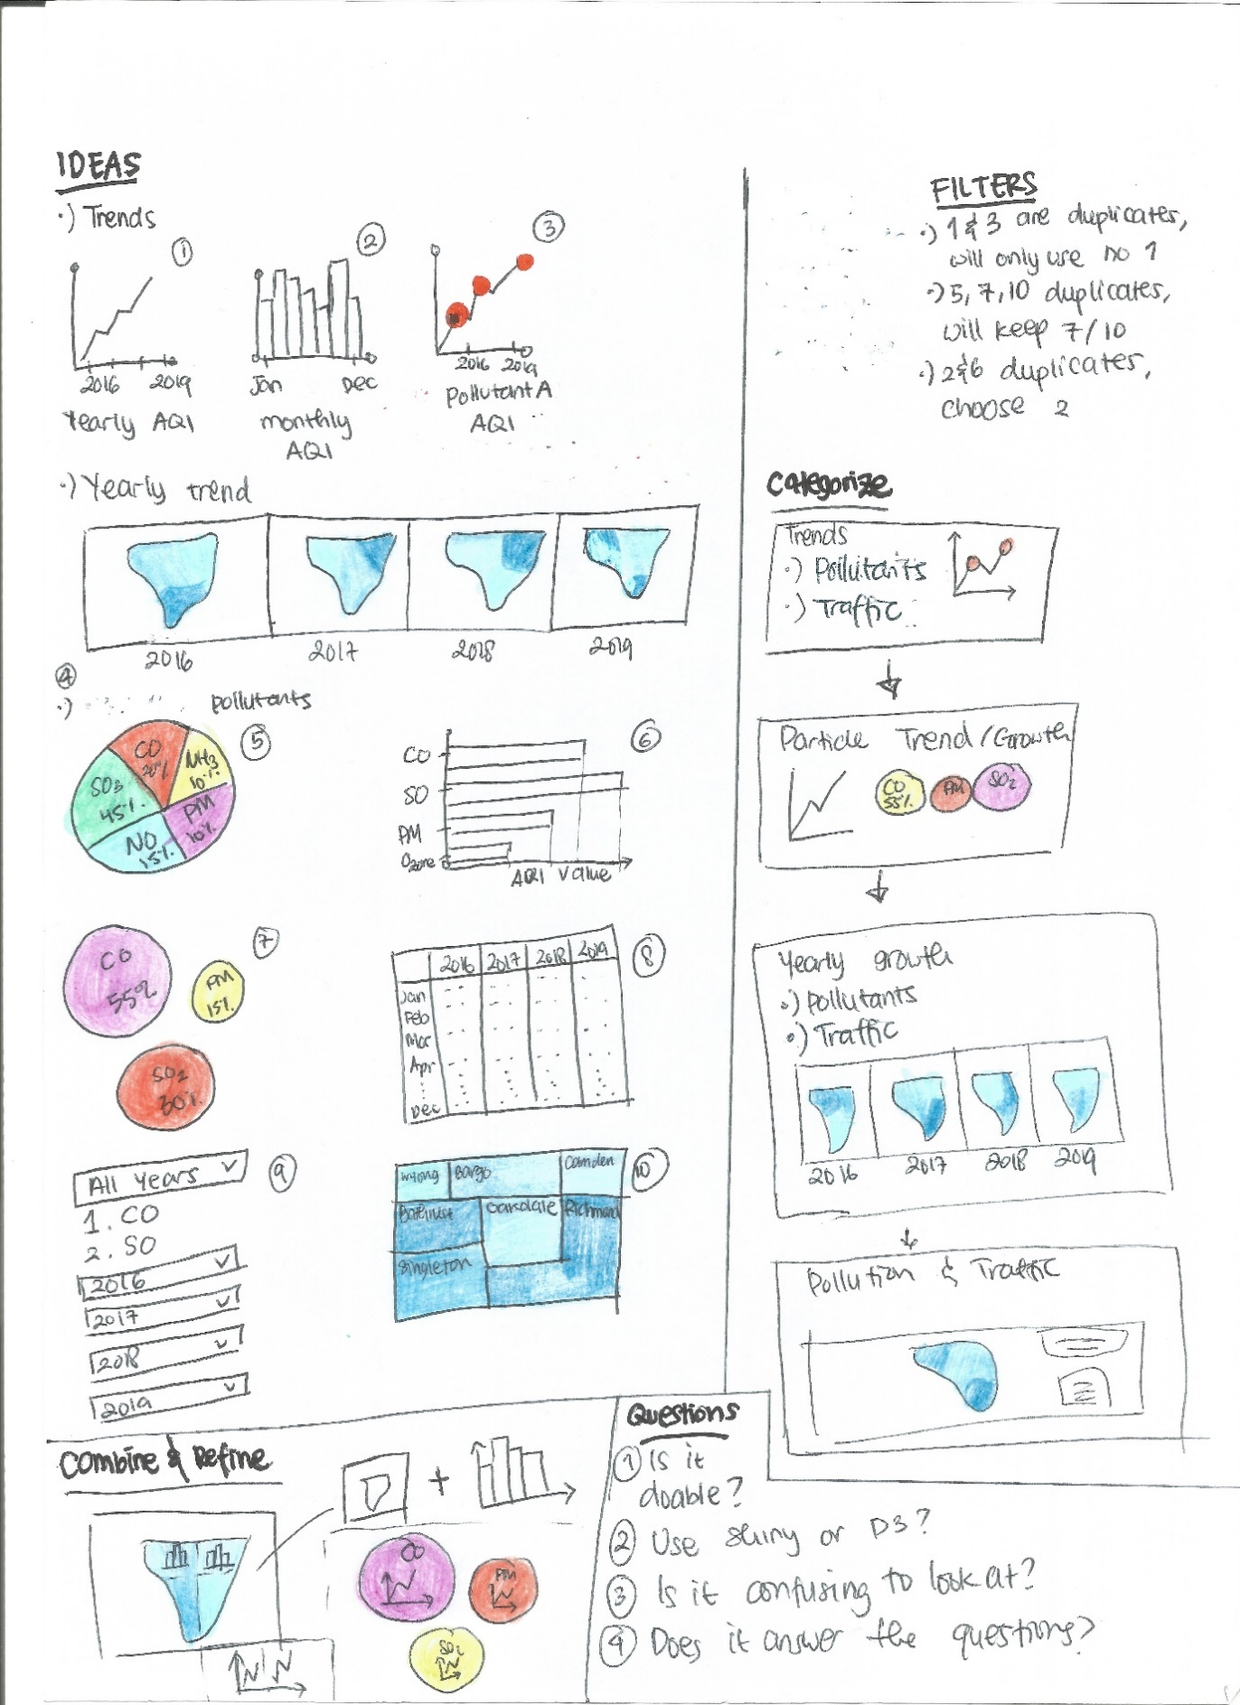

Page 2 of five design sheet

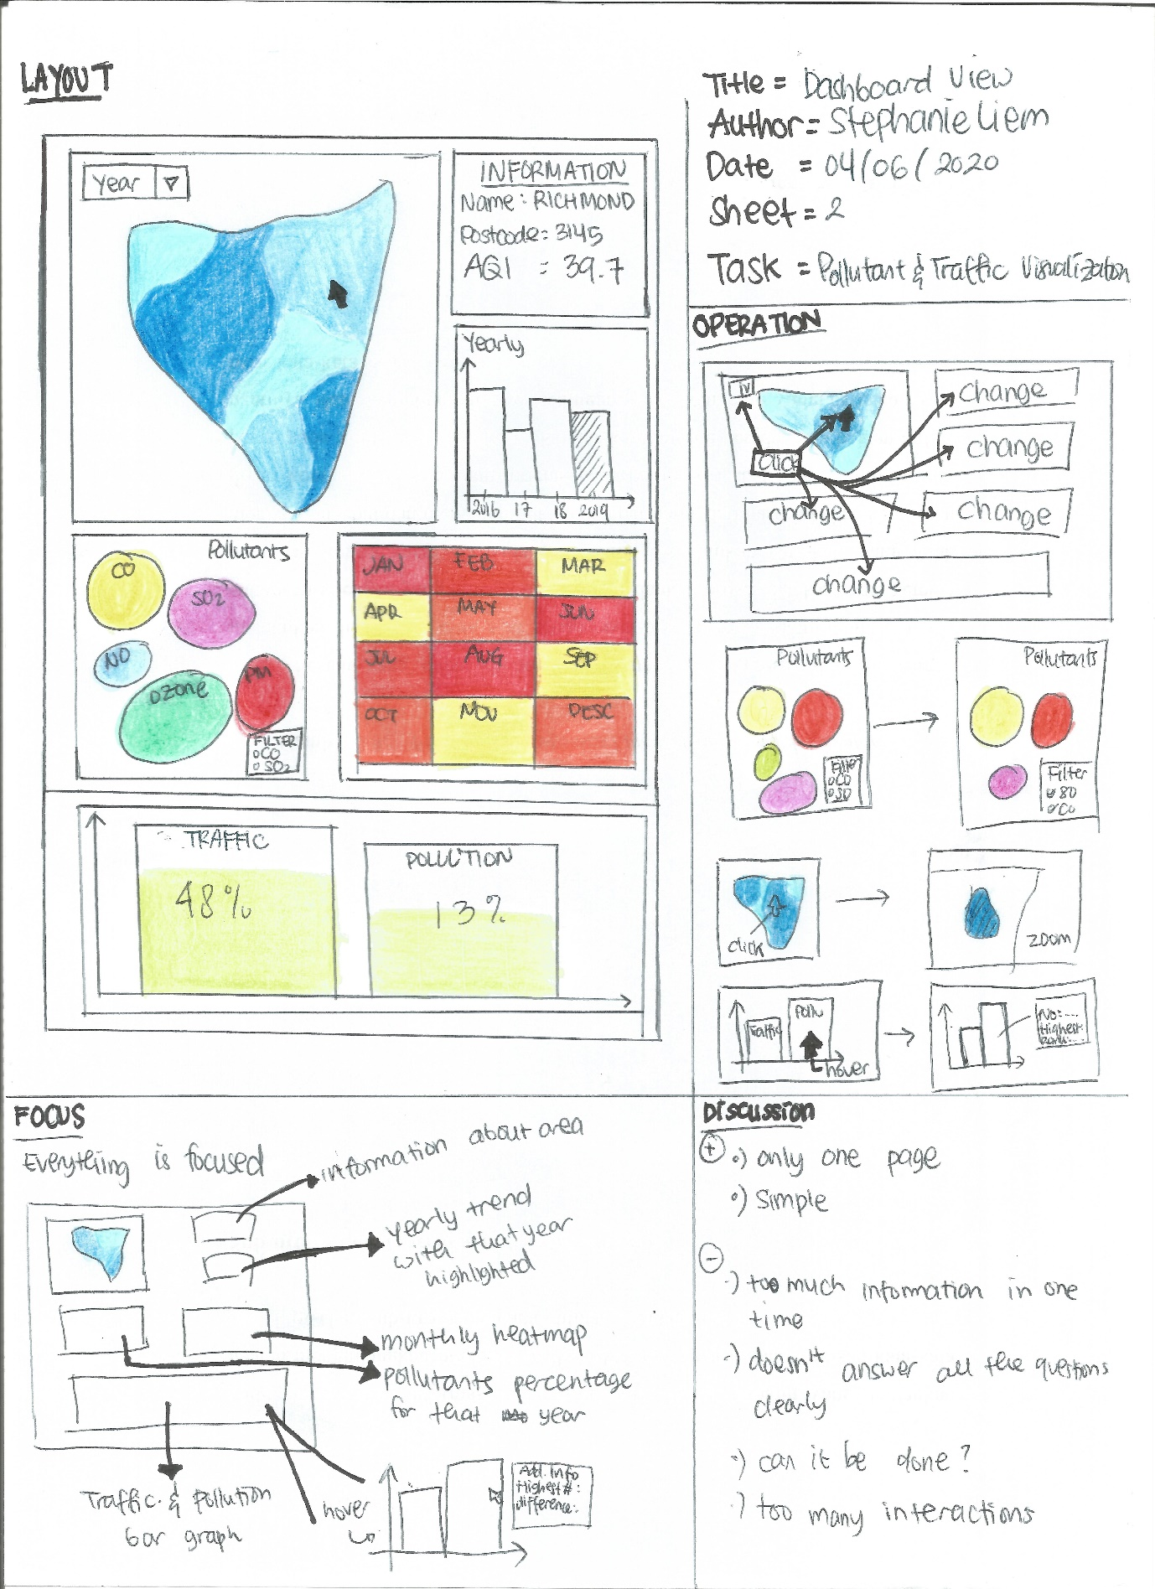

Page 3 of five design sheet

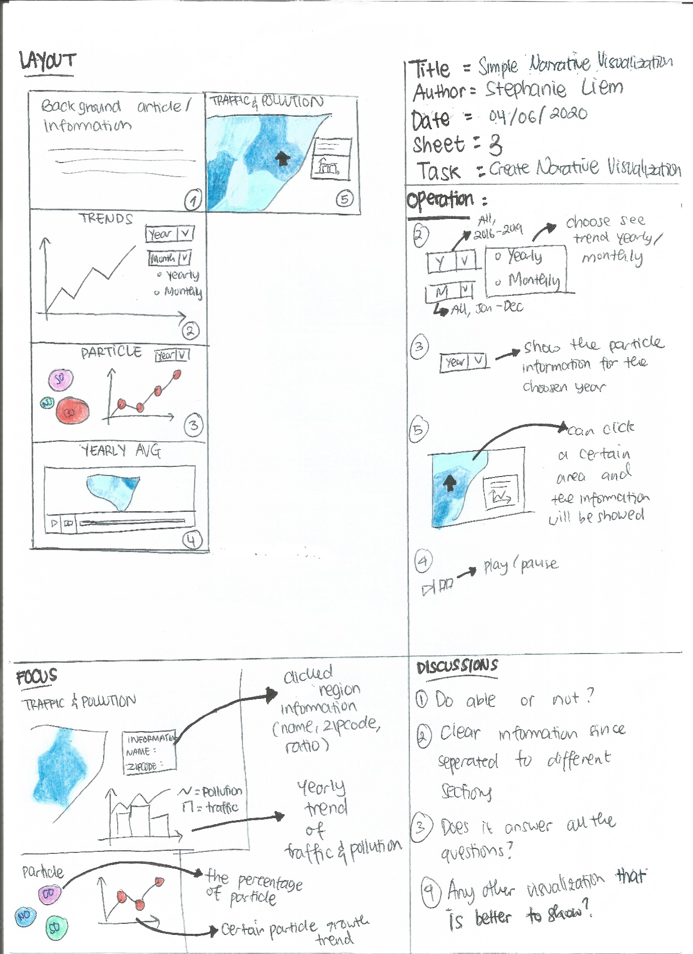

Page 4 of five design sheet

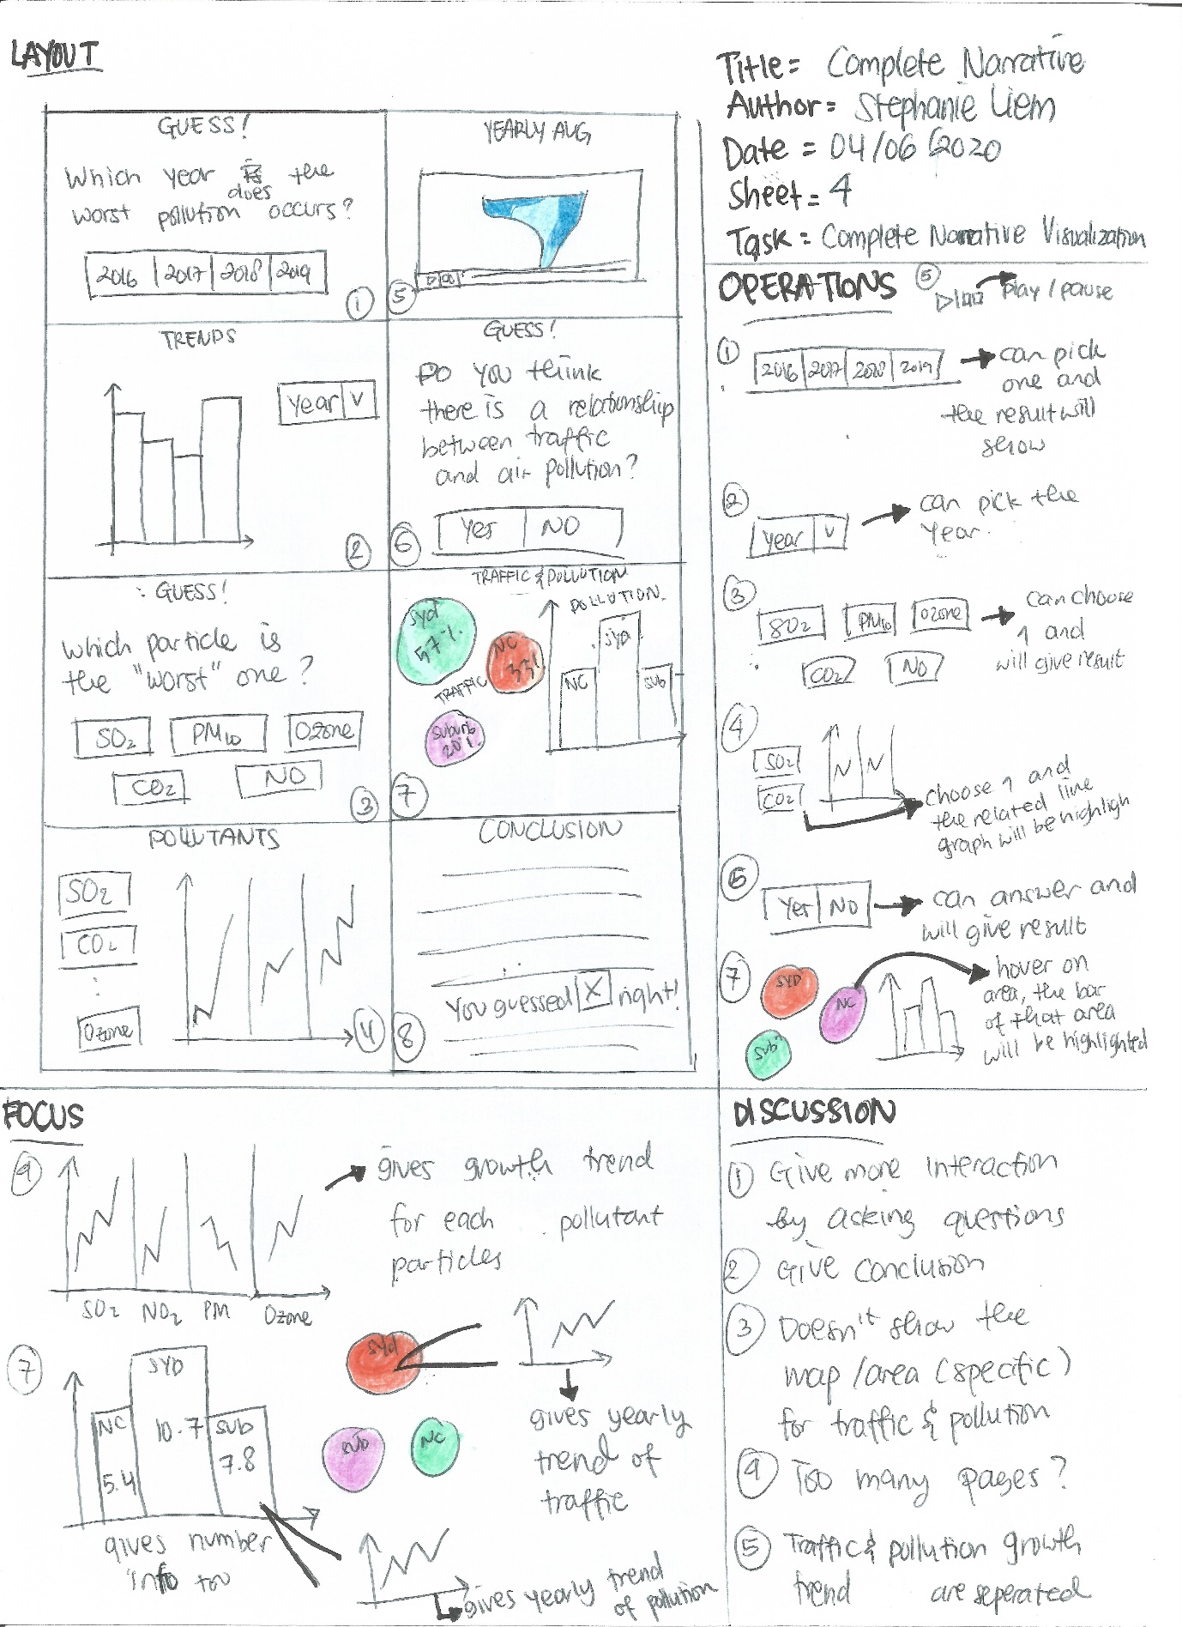

Page 5 of five design sheet

